无线与有线网络的集成实验
拓扑图
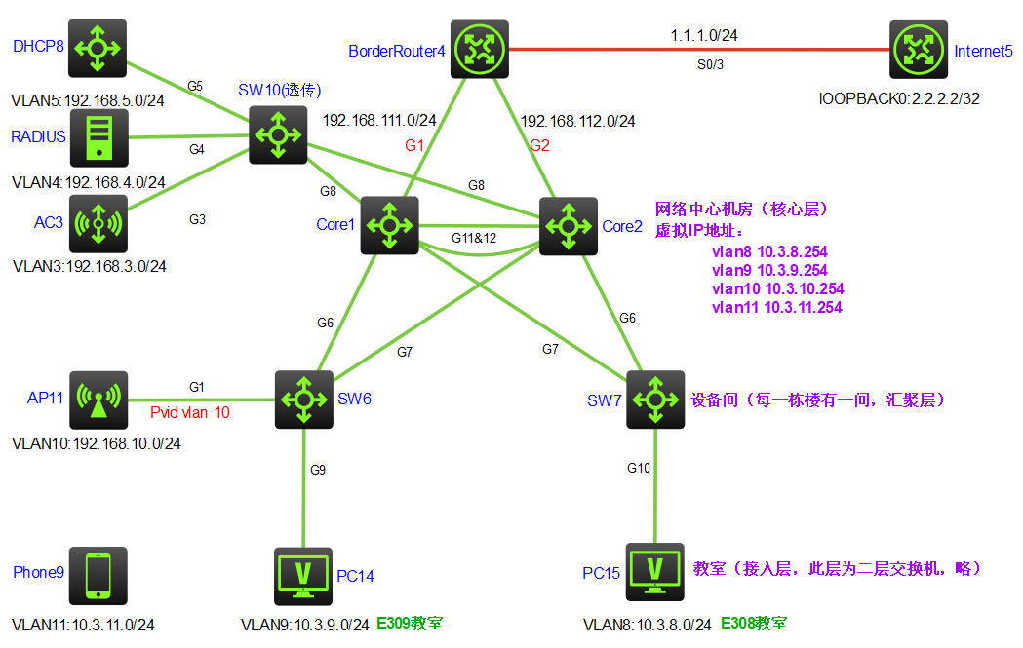
工程要求：
- 内网业务网段可通过NAT方式访问公网，管理网段不可访问公网（ACL）；
- 实现内网互通；
- 利用VRRP技术实现网关的备份；
- 核心交换机之间利用链路聚合实现带宽扩展及链路备份；
- 利用MSTP技术实现二层链路与设备备份及负载分担；
- 无线网络以AP+AC方式组网，AP需进行三层认证，无线业务流量通过AP转发；
- 无线网络客户通过MAC认证方式（RADIUS服务器）接入网络，通过DHCP服务器取IP地址。
注：本实验用三层交换机来模拟DHCP服务器

有线网配置

配置业务VLAN及AP管理VLAN、MSTP、链路聚合
- SW6上配置
- VLAN接口配置
[SW6]vlan 6 to 9

[SW6]vlan 8
[SW6-vlan8]port g1/0/8

[SW6-GigabitEthernet1/0/8]int g 1/0/1
[SW6-GigabitEthernet1/0/1]port link-type trunk
[SW6-GigabitEthernet1/0/1]port trunk permit vlan 6 7
[SW6-GigabitEthernet1/0/1]port trunk pvid vlan 6

[SW6-GigabitEthernet1/0/1]int g1/0/6
[SW6-GigabitEthernet1/0/6]port link-type trunk
[SW6-GigabitEthernet1/0/6]port trunk permit vlan 6 to 9
[SW6-GigabitEthernet1/0/6]int g1/0/7
[SW6-GigabitEthernet1/0/7]port link-type trunk
[SW6-GigabitEthernet1/0/7]port trunk permit vlan 6 to 9
[SW6-GigabitEthernet1/0/7]quit
- MSTP配置
[SW6]stp global enable
[SW6]stp region
[SW6]stp region-configuration
[SW6-mst-region]re
[SW6-mst-region]region-name test
[SW6-mst-region]instance 1 vlan 6 7 8
[SW6-mst-region]instance 2 vlan 9
[SW6-mst-region]active region-configuration
[SW6-mst-region]quit
- SW7上配置
- VLAN接口配置
[SW7]vlan 6 to 9

[SW7]vlan 9
[SW7-vlan9]port g1/0/9

[SW7-vlan9]int g1/0/6
[SW7-GigabitEthernet1/0/6]port link-type trunk
[SW7-GigabitEthernet1/0/6]port trunk permit vlan 6 to 9
[SW7-GigabitEthernet1/0/6]int g1/0/7
[SW7-GigabitEthernet1/0/7]port link-type trunk
[SW7-GigabitEthernet1/0/7]port trunk permit vlan 6 to 9
[SW7-GigabitEthernet1/0/7]quit
- MSTP配置
[SW7]stp global enable
[SW7]stp mode mstp
[SW7]stp region
[SW7]stp region-configuration
[SW7-mst-region]re
[SW7-mst-region]region-name test
[SW7-mst-region]instance 1 vlan 6 7 8
[SW7-mst-region]instance 2 vlan 9
[SW7-mst-region]active region-configuration
[SW7-mst-region]quit
- Core1上配置
- 配置链路聚合接口（组）
[Core1]interface Bridge-Aggregation 12
[Core1-Bridge-Aggregation12]interface g1/0/11
[Core1-GigabitEthernet1/0/11]port link-aggregation group 12
[Core1-GigabitEthernet1/0/12]interface g1/0/12
[Core1-GigabitEthernet1/0/12]port link-aggregation group 12
- VLAN及接口配置
[Core1-Bridge-Aggregation12]vlan 3 to 9
[Core1]vlan 111 /连接上行链路BorderRouter的VLAN

[Core1-vlan111]port g1/0/1
[Core1-vlan111]int g1/0/6
[Core1-GigabitEthernet1/0/6]port link-type trunk
[Core1-GigabitEthernet1/0/6]port trunk permit vlan 6 to 9
[Core1-GigabitEthernet1/0/6]int g1/0/7
[Core1-GigabitEthernet1/0/7]port link-type trunk
[Core1-GigabitEthernet1/0/7]port trunk permit vlan 6 to 9

[Core1-GigabitEthernet1/0/7]interface Bridge-Aggregation 12
[Core1-Bridge-Aggregation12] port link-type trunk
[Core1-Bridge-Aggregation12] port trunk permit vlan 1 6 to 9

[Core1-Bridge-Aggregation12]interface g1/0/8
[Core1-GigabitEthernet1/0/8]port link-type trunk
[Core1-GigabitEthernet1/0/8]port trunk permit vlan 3 to 5
[Core1-GigabitEthernet1/0/8]undo stp enable
[Core1-GigabitEthernet1/0/8]quit
- MSTP配置
[Core1]stp global enable
[Core1]stp region
[Core1]stp region-configuration
[Core1-mst-region]re
[Core1-mst-region]region-name test
[Core1-mst-region]instance 1 vlan 6 7 8
[Core1-mst-region]instance 2 vlan 9
[Core1-mst-region]active region-configuration
[Core1-mst-region]quit
- Core2上配置
- 创建链路聚合接口（组）
[Core2]interface Bridge-Aggregation 12
[Core2-Bridge-Aggregation12]interface g1/0/11
[Core2-GigabitEthernet1/0/11]port link-aggregation group 12
[Core2-GigabitEthernet1/0/12]interface g1/0/12
[Core2-GigabitEthernet1/0/12]port link-aggregation group 12

- VLAN及接口配置
[Core2-Bridge-Aggregation12]vlan 3 to 9
[Core2]vlan 112 /连接上行链路BorderRouter的VLAN

[Core2-vlan112]port g1/0/2
[Core2-vlan112]int g1/0/6
[Core2-GigabitEthernet1/0/6]port link-type trunk
[Core2-GigabitEthernet1/0/6]port trunk permit vlan 6 to 9
[Core2-GigabitEthernet1/0/6]int g1/0/7
[Core2-GigabitEthernet1/0/7]port link-type trunk
[Core2-GigabitEthernet1/0/7]port trunk permit vlan 6 to 9

[Core2-GigabitEthernet1/0/7]interface Bridge-Aggregation 12
[Core2-Bridge-Aggregation12] port link-type trunk
[Core2-Bridge-Aggregation12] port trunk permit vlan 1 6 to 9

[Core2-Bridge-Aggregation12]interface g1/0/9
[Core2-GigabitEthernet1/0/9]port link-type trunk
[Core2-GigabitEthernet1/0/9]port trunk permit vlan 3 to 5
[Core2-GigabitEthernet1/0/9]undo stp enable
[Core2-GigabitEthernet1/0/9]quit
- MSTP配置
[Core2]stp global enable
[Core2]stp region
[Core2]stp region-configuration
[Core2-mst-region]re
[Core2-mst-region]region-name test
[Core2-mst-region]instance 1 vlan 6 7 8
[Core2-mst-region]instance 2 vlan 9
[Core2-mst-region]active region-configuration
[Core2-mst-region]quit
- SW10上VLAN及接口配置
[SW10]vlan 3 to 5

[SW10]vlan 3
[SW10-vlan3]port g1/0/3
[SW10-vlan3]vlan 4
[SW10-vlan4]port g1/0/4
[SW10-vlan4]vlan 5
[SW10-vlan5]port g1/0/5
[SW10-vlan5]interface g1/0/8
[SW10-GigabitEthernet1/0/8]port link-type trunk
[SW10-GigabitEthernet1/0/8]port trunk permit vlan 3 to 5
[SW10-GigabitEthernet1/0/8]int g1/0/9
[SW10-GigabitEthernet1/0/9]port link-type trunk
[SW10-GigabitEthernet1/0/9]port trunk permit vlan 3 to 5
- DHCP、AC上VLAN及接口配置
[DHCPServer]vlan 5
[DHCPServer-vlan5]port g1/0/5
[DHCPServer-vlan5]

[AC]vlan 3
[AC-vlan3]port g1/0/3
[AC-vlan3]quit
- 链路聚合、MSTP配置验证
- 链路聚合配置验证（以Core1为例）
[Core1-Bridge-Aggregation12]dis link-aggregation summary
Aggregation Interface Type:
BAGG -- Bridge-Aggregation, BLAGG -- Blade-Aggregation, RAGG -- Route-Aggregation, SCH-B -- Schannel-Bundle
Aggregation Mode: S -- Static, D -- Dynamic
Loadsharing Type: Shar -- Loadsharing, NonS -- Non-Loadsharing
Actor System ID: 0x8000, 8893-e82c-0200

AGG AGG Partner ID Selected Unselected Individual Share
Interface Mode Ports Ports Ports Type
-------------------------------------------------------------------------------
BAGG12 S None 2 0 0 Shar
- MSTP配置验证（以Core1、SW6为例）
[Core1]dis stp brief
MST ID Port Role STP State Protection
0 Bridge-Aggregation12 DESI FORWARDING NONE
0 GigabitEthernet1/0/1 DESI FORWARDING NONE
0 GigabitEthernet1/0/6 DESI FORWARDING NONE
0 GigabitEthernet1/0/7 DESI FORWARDING NONE
1 Bridge-Aggregation12 DESI FORWARDING NONE
1 GigabitEthernet1/0/6 DESI FORWARDING NONE
1 GigabitEthernet1/0/7 DESI FORWARDING NONE
2 Bridge-Aggregation12 DESI FORWARDING NONE
2 GigabitEthernet1/0/6 DESI FORWARDING NONE
2 GigabitEthernet1/0/7 DESI FORWARDING NONE
<SW6>dis stp brief
MST ID Port Role STP State Protection
0 GigabitEthernet1/0/1 DESI FORWARDING NONE
0 GigabitEthernet1/0/6 ROOT FORWARDING NONE
0 GigabitEthernet1/0/7 ALTE DISCARDING NONE
0 GigabitEthernet1/0/8 DESI FORWARDING NONE
1 GigabitEthernet1/0/1 DESI FORWARDING NONE
1 GigabitEthernet1/0/6 ROOT FORWARDING NONE
1 GigabitEthernet1/0/7 ALTE DISCARDING NONE
1 GigabitEthernet1/0/8 DESI FORWARDING NONE
2 GigabitEthernet1/0/6 ROOT FORWARDING NONE
2 GigabitEthernet1/0/7 ALTE DISCARDING NONE

设备IP地址配置
- AC上IP地址配置
[AC]interface vlan 3
[AC-Vlan-interface3]ip ad 192.168.3.3 24
- DHCPServer上IP地址配置
[DHCPServer]interface vlan 5
[DHCPServer-Vlan-interface5]ip ad 192.168.5.3 24
- 核心交换机Core1上IP地址配置
[Core1]int vlan 3
[Core1-Vlan-interface3]ip ad 192.168.3.1 24
[Core1-Vlan-interface3]int vlan 4
[Core1-Vlan-interface4]ip ad 192.168.4.1 24
[Core1-Vlan-interface4]int vlan 5
[Core1-Vlan-interface5]ip ad 192.168.5.1 24
[Core1-Vlan-interface5]int vlan 6
[Core1-Vlan-interface6]ip ad 192.168.6.1 24
[Core1-Vlan-interface6]int vlan 7
[Core1-Vlan-interface7]ip ad 10.3.7.1 24
[Core1-Vlan-interface7]int vlan 8
[Core1-Vlan-interface8]ip ad 10.3.8.1 24
[Core1-Vlan-interface8]int vlan 9
[Core1-Vlan-interface9]ip ad 10.3.9.1 24
[Core1-Vlan-interface9]int vlan 111
[Core1-Vlan-interface111]ip ad 192.168.111.1 24
[Core1-Vlan-interface111]quit
- 核心交换机Core2上IP地址配置
[Core2]int vlan 3
[Core2-Vlan-interface3]ip ad 192.168.3.2 24
[Core2-Vlan-interface3]int vlan 4
[Core2-Vlan-interface4]ip ad 192.168.4.2 24
[Core2-Vlan-interface4]int vlan 5
[Core2-Vlan-interface5]ip ad 192.168.5.2 24
[Core2-Vlan-interface5]int vlan 6
[Core2-Vlan-interface6]ip ad 192.168.6.2 24
[Core2-Vlan-interface6]int vlan 7
[Core2-Vlan-interface7]ip ad 10.3.7.2 24
[Core2-Vlan-interface7]int vlan 8
[Core2-Vlan-interface8]ip ad 10.3.8.2 24
[Core2-Vlan-interface8]int vlan 9
[Core2-Vlan-interface9]ip ad 10.3.9.2 24
[Core2-Vlan-interface9]int vlan 112
[Core2-Vlan-interface112]ip ad 192.168.112.1 24
[Core2-Vlan-interface112]quit
- BorderRouter4边界路由器上IP地址配置
[BorderRouter]int g 0/0/1
[BorderRouter-GigabitEthernet0/0/1]ip ad 192.168.111.2 24
[BorderRouter-GigabitEthernet0/0/1]int g 0/0/2
[BorderRouter-GigabitEthernet0/0/2]ip ad 192.168.112.2 24
[BorderRouter-GigabitEthernet0/0/2]int s0/0/3
[BorderRouter-Serial0/0/3]ip ad 1.1.1.2 24
[BorderRouter-Serial0/0/3]quit
- Inernet路由上IP地址配置
[Internet]int s0/0/3
[Internet-Serial0/0/3]ip a 1.1.1.1 24
[Internet-Serial0/0/3]int loopback0
[Internet-LoopBack0]ip ad 2.2.2.2 32

VRRP冗余网关配置与验证（核心交换机）
- 核心交换机Core1配置
- 链路监测组配置
[Core1]track 1 interface g1/0/1
[Core1-track-1]track 6 interface g1/0/6
[Core1-track-6]track 7 interface g1/0/7
[Core1-track-7]quit
注：track 1为VLAN6、7、8、9监测上行链路G1/0/1；track 6和track 7为VLAN3、4、5分别监测下行链路G1/0/6和G1/0/7！
- VRRP配置
[Core1]int vlan 6
[Core1-Vlan-interface6]vrrp vrid 6 virtual-ip 192.168.6.254
[Core1-Vlan-interface6]vrrp vrid 6 priority 110
[Core1-Vlan-interface6]vrrp vrid 6 track 1 priority reduced 40

[Core1-Vlan-interface6] int vlan 7
[Core1-Vlan-interface7]vrrp vrid 7 virtual-ip 10.3.7.254
[Core1-Vlan-interface7]vrrp vrid 7 priority 110
[Core1-Vlan-interface7]vrrp vrid 7 track 1 priority reduced 40

[Core1-Vlan-interface7]int vlan 8
[Core1-Vlan-interface8]vrrp vrid 8 virtual-ip 10.3.8.254
[Core1-Vlan-interface8]vrrp vrid 8 priority 110
[Core1-Vlan-interface8]vrrp vrid 8 track 1 priority reduced 40

[Core1-Vlan-interface8]int vlan 9
[Core1-Vlan-interface9]vrrp vrid 9 virtual-ip 10.3.9.254

[Core1-Vlan-interface9]int vlan 3
[Core1-Vlan-interface3]vrrp vrid 3 virtual-ip 192.168.3.254
[Core1-Vlan-interface3]vrrp vrid 3 priority 110
[Core1-Vlan-interface3]vrrp vrid 3 track 6 priority reduced 40
[Core1-Vlan-interface3]vrrp vrid 3 track 7 priority reduced 40

[Core1-Vlan-interface3]int vlan 4
[Core1-Vlan-interface4]vrrp vrid 4 virtual-ip 192.168.4.254
[Core1-Vlan-interface4]vrrp vrid 4 priority 110
[Core1-Vlan-interface4]vrrp vrid 4 track 6 priority reduced 40
[Core1-Vlan-interface4]vrrp vrid 4 track 7 priority reduced 40

[Core1-Vlan-interface4]int vlan 5
[Core1-Vlan-interface5]vrrp vrid 5 virtual-ip 192.168.5.254
[Core1-Vlan-interface5]vrrp vrid 5 priority 110
[Core1-Vlan-interface5]vrrp vrid 5 track 6 priority reduced 40
[Core1-Vlan-interface5]vrrp vrid 5 track 7 priority reduced 40

[Core1-Vlan-interface5]quit
- 核心交换机Core2配置
- 上行链路监测组配置
[Core2]track 2 interface g1/0/2
[Core2-track-2]quit
- VRRP配置
[Core2]int vlan 6
[Core2-Vlan-interface6]vrrp vrid 6 virtual-ip 10.3.6.254

[Core2-Vlan-interface6]int vlan 7
[Core2-Vlan-interface7]vrrp vrid 7 virtual-ip 10.3.7.254

[Core2-Vlan-interface7]int vlan 8
[Core2-Vlan-interface8]vrrp vrid 8 virtual-ip 10.3.8.254

[Core2-Vlan-interface8]int vlan 9
[Core2-Vlan-interface9]vrrp vrid 9 virtual-ip 10.3.9.254
[Core2-Vlan-interface9]vrrp vrid 9 priority 110
[Core2-Vlan-interface9]vrrp vrid 9 track 2 priority reduced 40

[Core2-Vlan-interface9]int vlan 3
[Core2-Vlan-interface3]vrrp vrid 3 virtual-ip 10.3.3.254

[Core2-Vlan-interface3]int vlan 4
[Core2-Vlan-interface4]vrrp vrid 4 virtual-ip 10.3.4.254

[Core2-Vlan-interface4]int vlan 5
[Core2-Vlan-interface5]vrrp vrid 5 virtual-ip 10.3.5.254

- VRRP验证
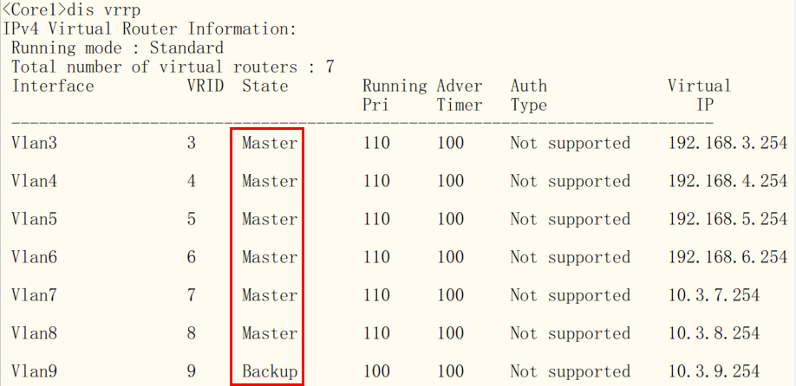
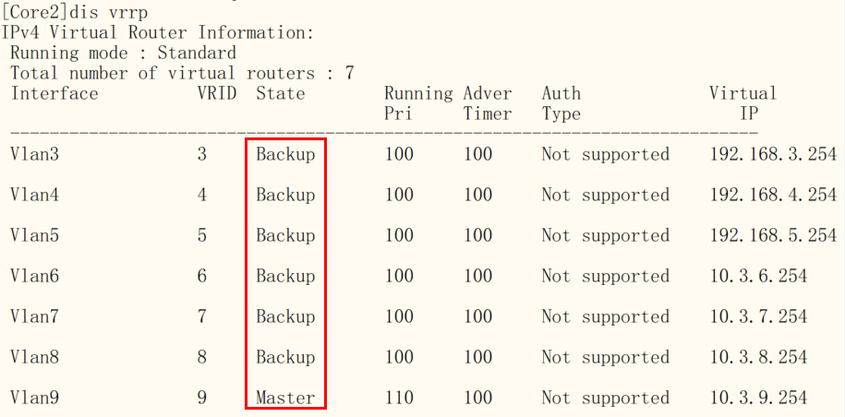

内网路由配置与测试
- AC上路由配置
[AC]ip route-static 0.0.0.0 0 192.168.3.254
- DHCP上路由配置
[DHCPServer]ip route-static 0.0.0.0 0 192.168.5.254
- RADIUS上IP与网关配置
IP/submask：192.168.4.3/24 gateway：192.168.4.254
- 核心交换机Core1上路由配置
[Core1]rip
[Core1-rip-1]network 0.0.0.0 /声明所有网段
[Core1-rip-1]quit
- 核心交换机Core2上路由配置
[Core2]rip
[Core2-rip-1]network 0.0.0.0 /声明所有网段
[Core2-rip-1]
- BorderRouter4边界路由器上路由配置
[BorderRouter]rip
[BorderRouter-rip-1]network 192.168.111.0
[BorderRouter-rip-1]network 192.168.112.0
[BorderRouter-rip-1]quit
- 内网路由测试
- 可从PC机去Ping边界路由器私网接口（192.168.111.2和192.168.112.2）
- 查看三层设备的路由表（display ip routing-table）

公网路由配置与测试（边界路由器）
- 边界路由器上公网路由配置
[BorderRouter]ip route-static 0.0.0.0 0 1.1.1.1 /默认路由指向公网
- 边界路由器上向内网发布公网路由
[BorderRouter]rip
[BorderRouter-rip-1]default-route only /利用RIP协议向内网发布去往公网的默认路由
- 边界路由器上公网路由测试
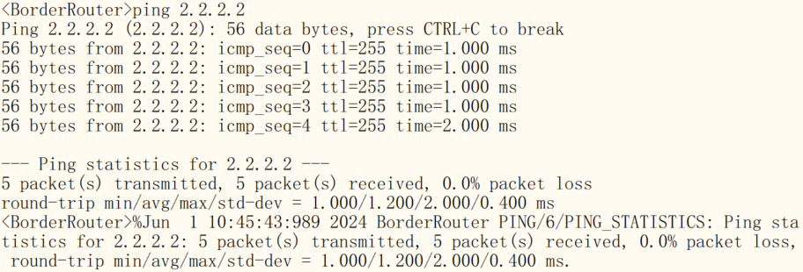

与NAT、ACL配置与（边界路由器）
在未配置NAT之前，内网无法访问公网。这里由于公网没有到达内网的路由（Internet路由器上无配置任何路由协议）。可以从PC上去ping公网的2.2.2.2来进行测试。
- 边界路由器上配置ACL与NAT
允许业务网段访问公网，禁止其他网段访问公网。
[BorderRouter]acl basic 2000
[BorderRouter-acl-ipv4-basic-2000]rule permit source 10.3.0.0 0.0.255.255
[BorderRouter-acl-ipv4-basic-2000]rule deny source any

[BorderRouter-acl-ipv4-basic-2000]int s0/0/3
[BorderRouter-Serial0/0/3]nat outbound 2000
- 测试ACL与NAT
可分别从PC、AC上分别去ping公网的2.2.2.2来进行测试，PC可达公网，而AC不可达公网。

无线网配置

配置DHCP服务器
建立两个地址池。其中一个地址池给AP（VLAN6）分配IP地址、网关；另一个地址池给无线业务VLAN的无线设备（移动用户）（VLAN7）分配IP地址及网关。
[DHCPServer]dhcp enable /使能DHCP服务

[DHCPServer]dhcp server ip-pool APvlan /AP的地址池
[DHCPServer-dhcp-pool- APvlan]network 192.168.6.0 24 /配置地址池范围
[DHCPServer-dhcp-pool- APvlan]gateway-list 192.168.6.254 /配置网关地址
[DHCPServer-dhcp-pool- APvlan]forbidden-ip 192.168.6.1 192.168.6.2 192.168.6.254 /配置禁止给AP分配的三个IP地址
[DHCPServer-dhcp-pool- APvlan]option 43 hex 8007000001c0a80303 /option43携带AC的IP地址

[DHCPServer]dhcp server ip-pool Clientvlan /无线业务VLAN的地址池
[DHCPServer-dhcp-pool- Clientvlan]network 10.3.7.0 24
[DHCPServer-dhcp-pool- Clientvlan]gateway-list 10.3.7.254
[DHCPServer-dhcp-pool- Clientvlan]forbidden-ip 10.3.7.1 10.3.7.2 10.3.7.254 /禁止给Client分配的三个IP地址

配置DHCP中继（Core1和Core2）
- Core1上配置DHCP中继
[Core1]dhcp enable

[Core1]int vlan 6
[Core1-Vlan-interface6]dhcp select relay
[Core1-Vlan-interface6]dhcp relay server-address 192.168.5.3

[Core1-Vlan-interface6]int vlan 7
[Core1-Vlan-interface7]dhcp select relay
[Core1-Vlan-interface7]dhcp relay server-address 192.168.5.3
- Core2上配置DHCP中继
[Core2]dhcp enable

[Core2]int vlan 6
[Core2-Vlan-interface6]dhcp select relay
[Core2-Vlan-interface6]dhcp relay server-address 192.168.5.3

[Core2-Vlan-interface6]int vlan 7
[Core2-Vlan-interface7]dhcp select relay
[Core2-Vlan-interface7]dhcp relay server-address 192.168.5.3

配置AC
- 配置RADIUS服务器参数
# 创建名为lu的RADIUS方案，并进入其视图
[AC]radius scheme lu
# 配置主认证、计费RADIUS服务器的IP地址为192.168.4.3
[AC-radius-lu]primary authentication 192.168.4.3
[AC-radius-lu]primary accounting 192.168.4.3
# 配置RADIUS认证、计费报文的共享密钥为h3c（注意：此密钥与认证服务器上设置的密钥相同）
[AC-radius-lu]key authentication simple h3c
[AC-radius-lu]key accounting simple h3c
# 配置发送给RADIUS服务器的用户名不携带域名
[AC-radius-lu]user-name-format without-domain
# 配置AC发送RADIUS报文使用的源IP地址为192.168.3.3（AC上VLAN3接口地址）
[AC-radius-lu]nas-ip 192.168.3.3
- 配置用户认证的域
# 创建名为lu的ISP域，并进入其视图
[AC-radius-lu]domain lu
# 为lan-access用户配置认证、授权、计费方案为RADIUS方案lu
[AC-isp-lu]authentication lan-access radius-scheme lu
[AC-isp-lu]authorization lan-access radius-scheme lu
[AC-isp-lu]accounting lan-access radius-scheme lu
[AC-isp-lu]quit
# 配置MAC地址认证的用户名和密码均为用户的MAC地址，且不带连字符（缺省配置）
[AC]mac-authentication user-name-format mac-address without-hyphen lowercase

- 配置无线服务模板
# 创建无线服务模板lu，并进入无线服务模板视图
[AC] wlan service-template lu
# 配置SSID为lu
[AC-wlan-st-lu] ssid lu
# 配置客户端接入认证方式为MAC地址认证
[AC-wlan-st-lu] client-security authentication-mode mac
# 配置MAC地址认证用户使用的ISP域为lu
[AC-wlan-st-lu] mac-authentication domain lu
[AC-wlan-st-lu]client forwarding-location ap /配置无线业务报文由AP转发
[AC-wlan-st-lu] service-template enable /使能服务模板
[AC-wlan-st-lu] quit
- 创建AP，配置AP接入认证，配置主备AC
# 创建AP，配置AP名称为ap1，型号名称选择WA6320-hcl，并配置序列号为H3C_88-9f-24-95-0b-00（使用dis device manuinfo命令在AP上查看DEVICE_SERIAL_NUMBER）
[AC] wlan ap ap1 model WA6320-hcl
[AC-wlan-ap-ap1] serial-id H3C_88-9f-24-95-0b-00
[AC-wlan-ap-ap1] map-configuration apcfg.txt
注意：apcfg.txt文件需在PC上制作好后上传至AC；apcfg.txt内容如下
system-view
vlan 7
quit
int g0/0/1
port link-type trunk
port trunk permit vlan 7
quit
[AC-wlan-ap-ap1] radio 1
#将服务模板lu绑定在射频1接口上
[AC-wlan-ap-ap1-radio-1] service-template lu vlan 7
# 开启Radio 1的射频功能。
[AC-wlan-ap-ap1-radio-1] radio enable
[AC-wlan-ap-ap1-radio-1] quit
[AC-wlan-ap-ap1] quit

Radius服务器上配置
Radius服务器在物理机上安装，用虚拟网卡NIC: VirtualBox Host-Only Ethernet Adapter （IP地址配置为 192.168.10.2）连接到HCL。

用户名：参与接入的计算机的MAC地址（小写无连字符和空格）
密码： 参与接入的计算机的MAC地址（小写无连字符和空格）
NAS密钥：h3c （同radius服务器认证方案中的key authentication h3c和key accounting h3c）

RADIUS认证截图
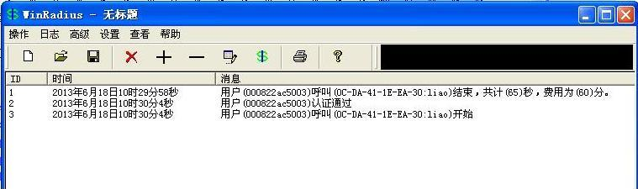
在radius服务器上添加一个账号进行连接，连接成功，计时开始
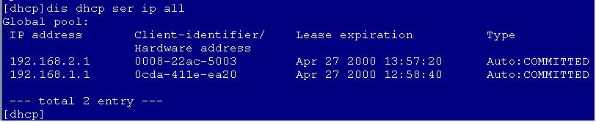这是在DHCP上的截图，客户机成功的获取到vlan 200网段的IP
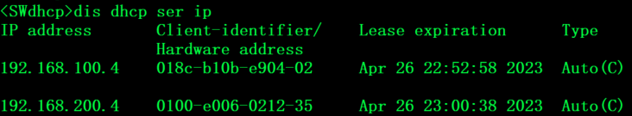
客户机连接，AC上的信息提示成功。

其他知识点
- RADIUS认证时为什么需要配置nas-ip？
- RADIUS服务器通过IP地址来标识认证接入设备，并根据收到的RADIUS报文的源IP地址（即NAS-IP）是否与Radius服务器上所管理(配置指定的信任认证接入设备的IP地址)的接入设备的IP地址匹配，来决定是否处理来自该认证接入设备的认证或计费请求。
- 为保证认证和计费报文可被Radius服务器正常接收并处理，认证接入设备上发送RADIUS报文使用的源IP地址必须与RADIUS服务器上配置指定的认证接入设备的IP地址保持一致。
- 缺省情况下，认证接入设备上未指定发送RADIUS报文使用的源IP地址，认证接入设备将使用到达RADIUS服务器的路由出接口的主IPv4地址或IPv6地址作为发送RADIUS报文的源IP地址。如果认证接入设备上发送RADIUS报文使用的源IP地址与RADIUS服务器上指定配置的认证接入设备的IP地址不一致，可采用nas-ip命令进行配置。
- 在接入设备上配置设备发送RADIUS报文使用的源IP地址（即NAS-IP）的方法有：
RADIUS方案视图下，通过如下命令配置NAS-IP，只对本RADIUS方案有效；且优先级高于系统视图下的配置。nas-ip { ipv4-address | interface interface-type interface-number | ipv6 ipv6-address }系统视图下，通过如下命令配置NAS-IP，对所有RADIUS方案有效；radius nas-ip { interface interface-type interface-number | { ipv4-address | ipv6 ipv6-address } [ vpn-instance vpn-instance-name ] }

配置NAS-IP的注意事项：
- 通过指定接口配置NAS-IP和通过指定IP来配置NAS-IP的方式不可同时使用，后配置的生效。
- 为避免物理接口故障时从服务器返回的报文不可达，可使用Loopback接口地址为发送RADIUS报文使用的源IP地址。

